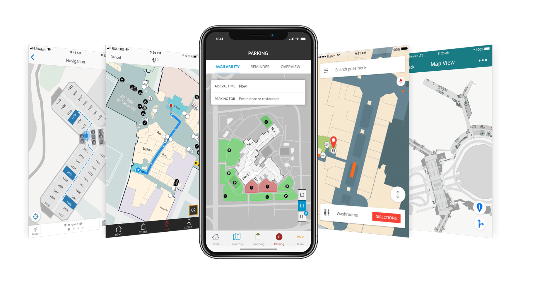

July 2018





**Vinay Iyer**, Account Executive | [viyer@jibestream.com](mailto:viyer@jibestream.com) | 647-292-2909

5

|  |
| --- |
| **Executive Summary**  Sonae Sierra is seeking proposals for wayfinding and indoor mapping solution for its portfolio of malls. We are excited to present Sonae Sierra with a proposal providing a customer centric solution that aligns with the its IT strategies and overall business goals. With the experience gained working with the largest malls and retailers globally in similar scope projects, we believe the advantages in choosing the Jibestream partner team are the following:  **Control**: The Jibestream solution is the most robust and flexible mapping platform available. Our platform provides Sonae Sierra with a highly-customized solution at an enterprise level. The depth of control available in our platform is a clear differentiator and second to none.  **Scale**: Choosing Jibestream is the fastest and the most efficient way to deliver an outstanding solution at scale.  **Experience**: The strength of Jibestream is our people who are subject matter experts in technology and complex indoor mapping. Projects are not accomplished with technology alone and require a highly skilled team of people that can problem solve and be solution oriented. Our team is the best in the industry and can instantly be an extension of the Sonae Sierra project team. Our team brings experience from industries beyond retail including, but not limited to, transportation, healthcare, airports, mass transit, and corporate campuses.  On behalf of our entire team, thank you for this exciting opportunity to start a relationship that will enable mutual success and achievements. |

/Users/Jibestream/Google Drive/Sales & Marketing/Sales Toolkit/Creatives/Logo - Partners and Clients/Mersin-city-hospital.png

**ABOUT JIBESTREAM**

Jibestream is the premier indoor mapping platform provider. The company’s map rendering engine merges the location dimension into enterprise solutions for real-time visual intelligence. Deployed through one of three native SDKs (Web, iOS, Android), developers can create tailored solutions using our SDKs and APIs while having centralized management of all associated data.

Founded in 2009, Jibestream’s solutions are deployed at 1000+ venues around the world.





**Jibestream’s Notable Clients**

|  |  |  |
| --- | --- | --- |
|  | Orlando Veteran’s Affair Medical Center | 1 million sq. ft. of facility space was digitized and stored in the Jibestream Content Management System and Jibestream’s native SDKs were integrated into Orlando VA’s iOS, Android, web, and touch-screen kiosks. indoo.rs Indoor Positioning was integrated to add support for ‘blue dot’ wayfinding. |
|  | Westfield Malls  (87 malls globally) | Jibestream’s SDKs are Integrated into Westfield’s iOS Android, web, and touch-screen kiosks. Integration with various core systems were made possible, including tenancy management. Maps were digitized for all 87 malls including the World Trade Center, NYC. |
|  | San Francisco Airport (San Francisco, California) | Jibestream’s SDKs are Integrated into SFO’s iOS Android, web, and touch-screen kiosks. indoo.rs Indoor Position platform was added to support ‘blue dot’ wayfinding and both current and future 3rd party data systems including Air-Trains. Persona-based use cases were implemented, for example: Public (traveler) and Private (employee) specific maps. |
|  | One Market Network | Recently selected as their long-term partner for a new product offering that is targeted to be deployed to over 1,500 new malls over the next 12 – 18 months |
|  | The Pentagon | [Sole sourced](https://govtribe.com/project/intent-to-award-sole-source-jibestream) in 2012 for platform’s unique capabilities, Jibestream continues to be the mapping provider for the Pentagon |
|  | Majid Al Futtaim | Deployed across MAF’s 13 luxury and high-end mall properties. Iconic properties include Mall of the Emirates and Mall of Egypt. |

****

**Commercially Deployed Examples (Retail)**

|  |  |
| --- | --- |
| One Market Network | * [**Westfield US iOS**](https://itunes.apple.com/ca/app/westfield-us/id397494939?)(https://itunes.apple.com/ca/app/westfield-us/id397494939?) * [**Westfield US Android**](https://play.google.com/store/apps/details?id=com.westfieldlabs.us.centre)(https://play.google.com/store/apps/details?id=com.westfieldlabs.us.centre) * [**Westfield UK iOS**](https://itunes.apple.com/ca/app/westfield-uk/id409824812?)(https://itunes.apple.com/ca/app/westfield-uk/id409824812?) * [**Westfield UK Android**](https://play.google.com/store/apps/%20details?id=com.westfieldlabs.uk.centre)(https://play.google.com/store/apps/details?id=com.westfieldlabs.uk.centre) * [**Westfield AU iOS**](https://itunes.apple.com/us/app/westfield-au/%20id390301687?)(https://itunes.apple.com/us/app/westfield-au/id390301687?) * [**Westfield AU Android**](https://play.google.com/store/apps/details?id=com.westfieldlabs.au.centre)(https://play.google.com/store/apps/details?id=com.westfieldlabs.au.centre) * Westfield web example: [**San Francisco Center**](https://www.westfield.com/sanfrancisco/center-info/map/49ers-team-store/51709#!/sanfrancisco)(https://www.westfield.com/sanfrancisco/center-info/map/49ers-team-store/51709#!/sanfrancisco) |
| General Growth Properties  (GGP) | * [**GGP iOS**](https://itunes.apple.com/ca/app/ggp-malls/id400510894?)(https://itunes.apple.com/ca/app/ggp-malls/id400510894?) * [**GGP Android**](https://play.google.com/store/apps/details?id=com.ggp.theclub&)(https://play.google.com/store/apps/details?id=com.ggp.theclub&) * GGP web example: [**Tyson Galleria**](https://www.tysonsgalleria.com/en/directory)(https://www.tysonsgalleria.com/en/directory/) |
| Majid Al Futtaim  (MAF) | * [**MAF iOS**](https://itunes.apple.com/ae/app/mall-of-the-emiratesmoe/id730035832?)(<https://itunes.apple.com/ae/app/mall-of-the-emiratesmoe/id730035832>?) * [**MAF Android**](https://play.google.com/store/apps/details?id=com.belongi.moe)(<https://play.google.com/store/apps/details?id=com.belongi.moe>) |



**Scope of Work**

**FRONTEND REQUIREMENTS**

**REQ 1.1 Browser Desktop Responsive: Fully Supported**

Jibestream’s native WEB SDK will work with any desktop browser that supports WebGL. We provide a canvas fallback for the Web SDK when WebGL is not available. Our maps are completely responsive. The map size, zoom, panning can be adjusted dynamically based on the layout.

**REQ 1.2 Browser Mobile Responsive: Fully Supported**

Jibestream’s native WEB SDK will work with any mobile browser that supports WebGL. We provide a canvas fallback for the Web SDK when WebGL is not available. Our maps are completely responsive. The map size, zoom, panning can be adjusted dynamically based on the layout.

**REQ 1.3 SDK Apple iOS: Fully Supported**

Jibestream offers a native iOS SDK. Minimum versions: iOS 9.0+. Device: iPhone 5 or higher

**REQ 1.4 SDK Android: Fully Supported**

Jibestream offers a native Android SDK. Minimum versions: Android Studio 2.0 or higher. Supported API Levels: 16 Android 4.1+

**REQ 1.5 Support for Windows Wayfinder with touch and virtual keyboard online and offline: Fully Supported**

Jibestream’s WEB SDK can be leveraged to work with Windows Wayfinder with touch and virtual keyboard.

Jibestream maps can cache locally so wayfinding will work seamlessly while offline as well as online.

**REQ 1.6 Multilanguage Support: Fully Supported**

Jibestream provides support for multiple UTF-8 languages. Jibestream has a number of commercial deployments around the world (Asia, Europe, Australia, North America) using multiple languages such as Arabic, Korean, Japanese, Chinese and more.

**REQ 1.7 Search per store, tag, brand, category, etc.: Fully Supported**

Jibestream allows metadata search functionalities. Jibestream also allows tagging of various data elements that can be used to implement search and categorization of data. We also allow keywords to be associated with Point of Interests (POIs), so instead of searching for “Starbucks”, one can also search for “coffee”.

Jibestream also offers predictive search functionalities.

**REQ 1.8 WebView integration on mobile devices: Fully Supported**

Jibestream’s native web SDK can be leveraged for WebView integration on mobile devices. This mobile app includes wayfinding and was built with WebView leveraging Apache Cordova: <https://www.kaleidahealth.org/mykaleida/app/>

**REQ 1.9 Route for normal and disabled People: Fully Supported**

Jibestream supports wayfinding for both of the above-mentioned options. Jibestream’s solution is completely ADA (Americans with Disabilities Act) compliant. Jibestream also provides Text Directions can be passed through a TTS (Text-To-Speech) library (regionally appropriate) and converted to audio instructions for the visually impaired.

See images below for an example from our deployment at the Mall of the Emirates.

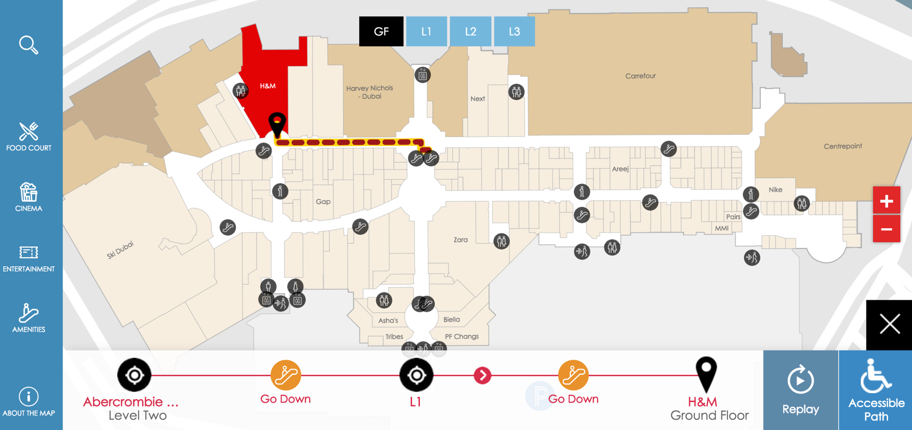

*Image 1 below shows regular wayfinding, where the user is navigating using escalators.*

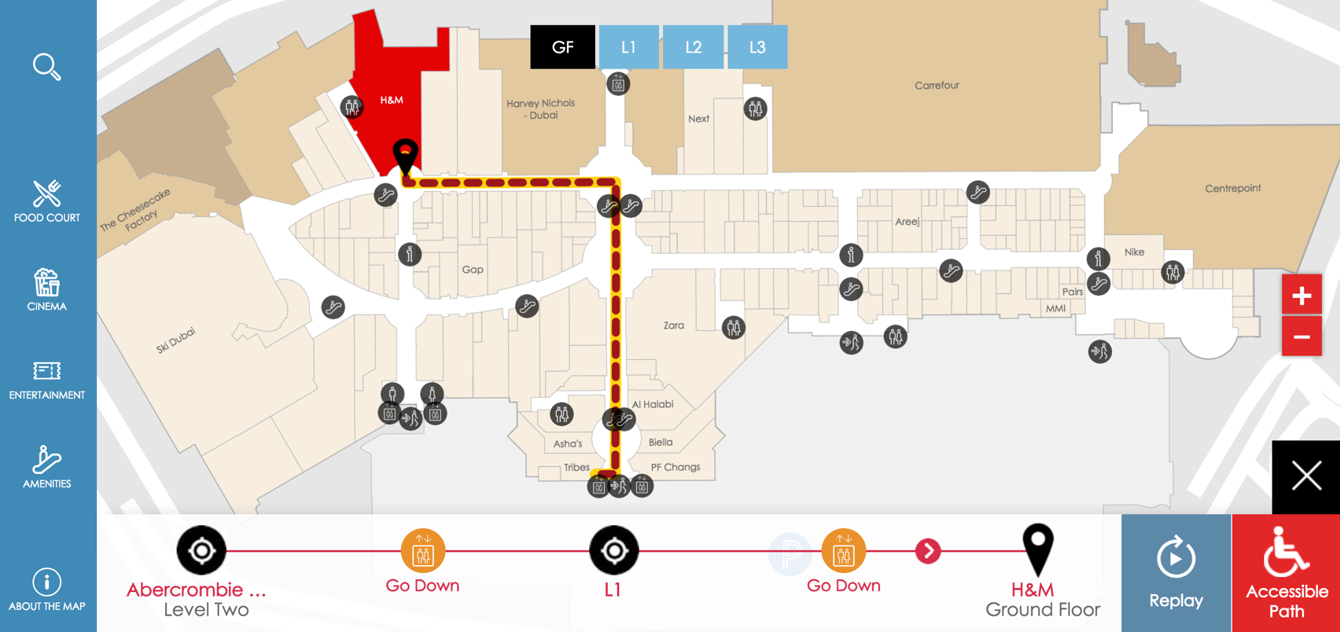

*Image 2 shows accessible (or disabled) wayfinding by avoiding “vertical movers” and navigation is done using the elevators instead.*

**REQ 1.10 Indoor localization integration WiFi, BLE, GPS (if outdoor): Fully Supported**

Jibestream maps are open and agnostic and as such, they can integrate with any Indoor Positioning Systems (IPS) including WiFi, BLE, UWB, Ultra-Sound, and GPS (if outdoor). Jibestream has been delivering IPS solutions for years and has a history of working with Cisco, indoo.rs, Mist Systems, Senion Labs, Navisense, and many more.

Below are some examples where we have deployed this solution:

* Westfield: Multiple Centres (Westfield + Senion)
* Kaleida Health: Commercially with Indoo.rs
* Cadillac Fairview: Markville Mall (with Indoo.rs)
* Veteran Affairs: Orlando VA Hospital (Commercially with Indoo.rs + a POC with Mist Systems)
* Facebook (POC with Mist Systems)
* Amgen (Corporate campus buildings with Indoo.rs)

**REQ 1.11 Indoor Navigation Turn by Turn, compatible with Blue Dot and AR routing experience if 1.10 is installed: Fully Supported**

Turn by Turn indoor navigation is fully compatible with both Blue Dot and is commercially deployed in 100s of venues. Although not commercially deployed, Jibestream’s R&D labs successfully tested and demoed our compatibility with AR in August 2017 (9 months before Google did theirs). See youtube link here: <https://www.youtube.com/watch?v=kfLzkQjKAbM&feature=youtu.be>

See image below for blue-dot example:

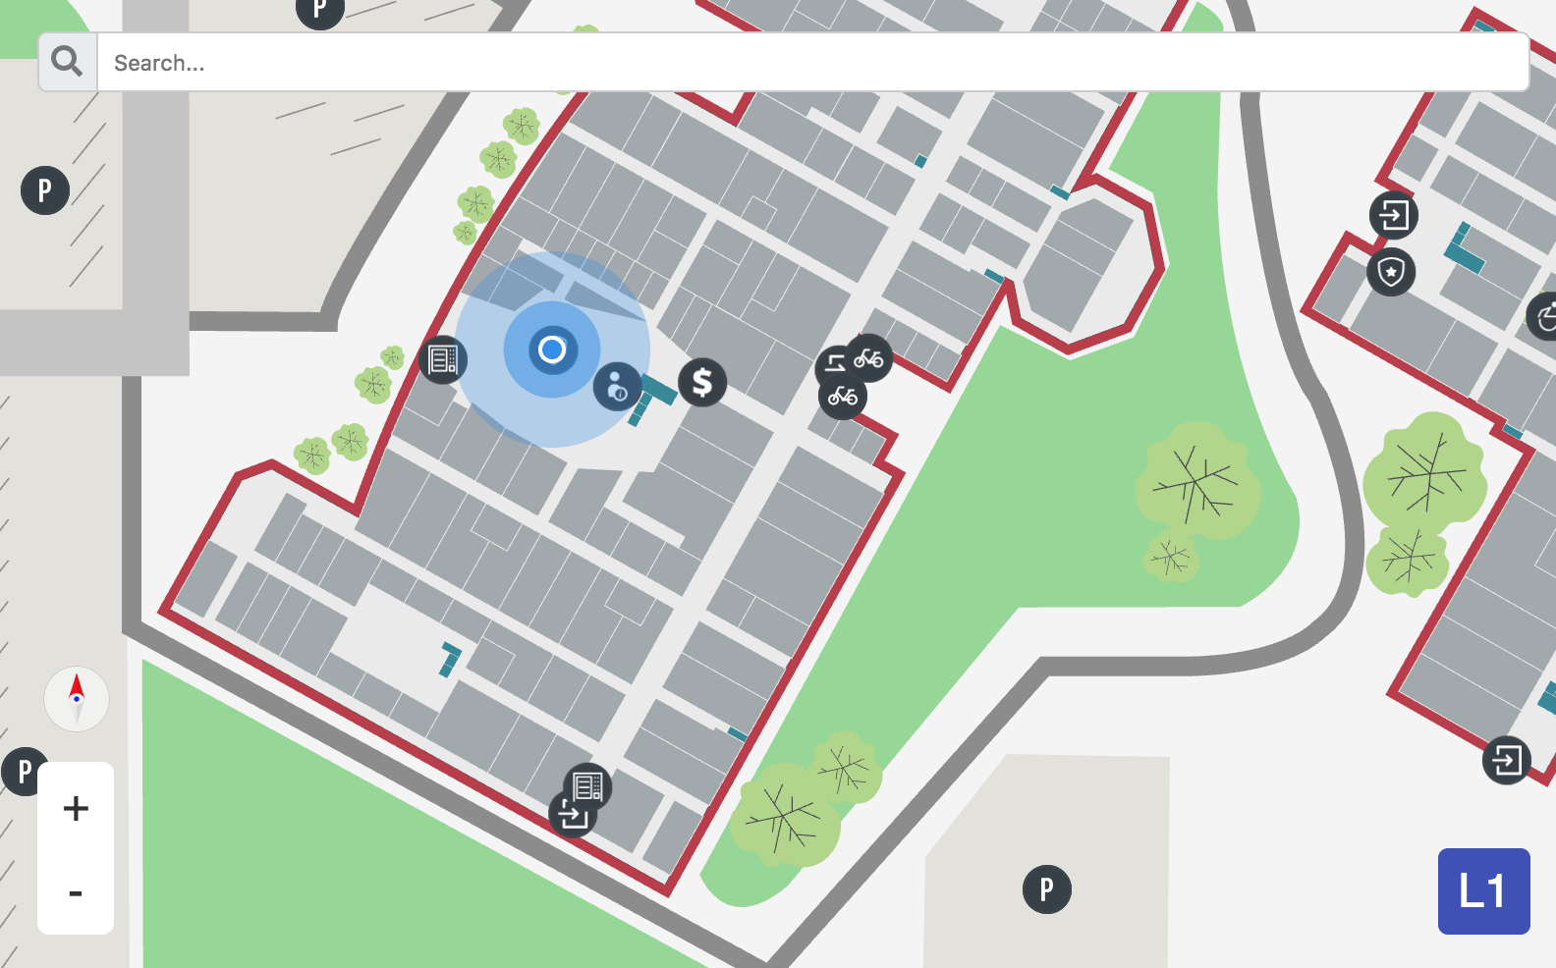

See image below from our AR demo:

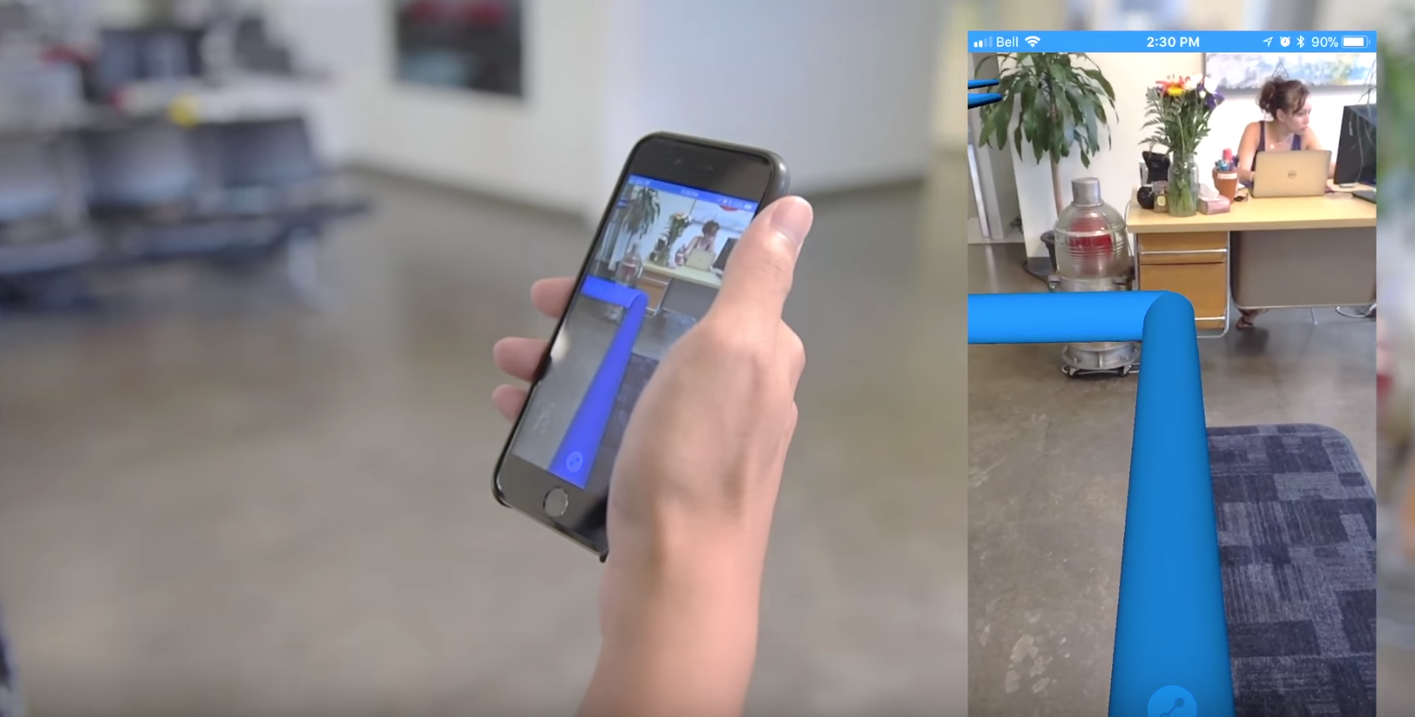

**REQ 1.12 Possibility to act as shopping directory without maps: Fully Supported**

Jibestream is a mapping platform only, so this feature has to be done on the implementation side. This feature has been successfully deployed commercially. Please see both of the examples below.

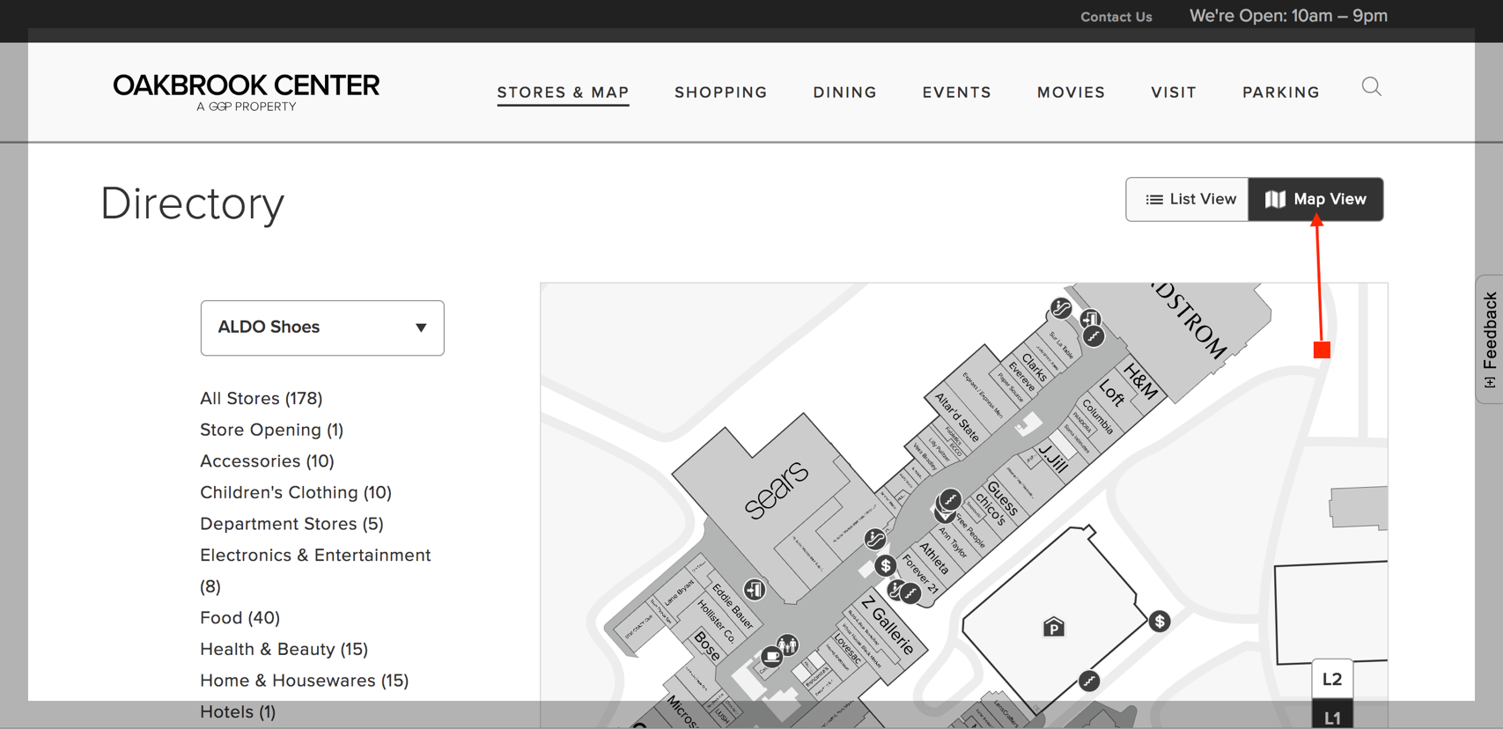

*Image 1 shows the map view*

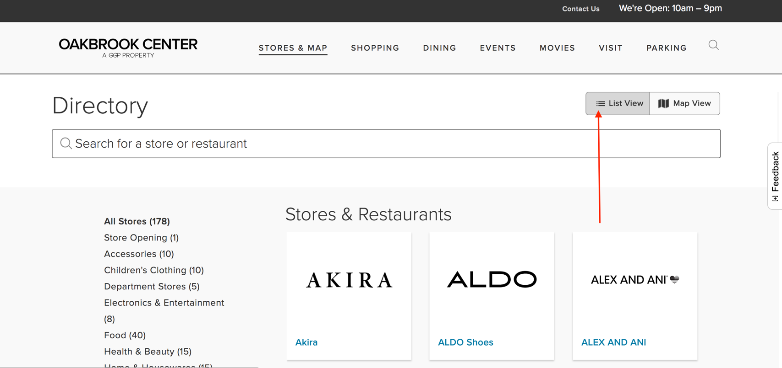

*Image 2 shows the directory view.*

**REQ 1.13 Possibility to use logos on maps: Fully Supported**

Jibestream allows you to add any object to the map. This includes images, text, or even HTML. See this example for a live rendering of our map showcasing this feature: <https://apps.jibestream.com/examples/add-html-to-map>

**BACKOFFICE REQUIREMENTS**

**REQ 2.1 Possibility to upload images, videos, logos, text, contacts per store, point of interest, and shopping information: Fully Supported**

Each destination is associated with a waypoint. Any amount of data can be associated with a waypoint either by using the Jibestream CMS or integrating it via our open APIs. Please see a screenshot of our CMS below to see an example on how you can associate data with a waypoint.

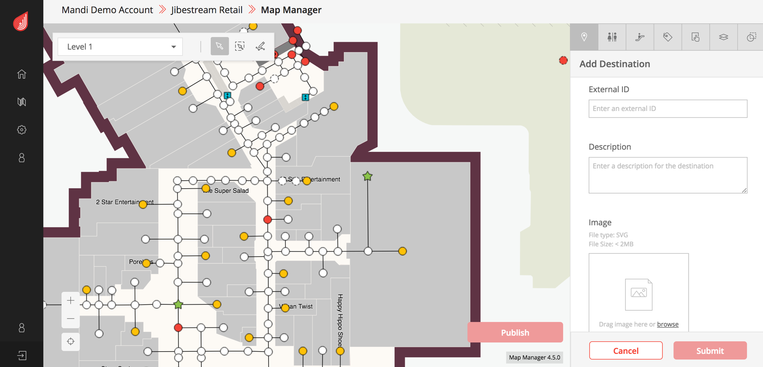

**REQ 2.2 Multilanguage support: Fully Supported**

The CMS is currently only available in English, but because it is browser based, it can leverage browser based language conversion. This has not been an issue in previous deployments given that the UI mostly icon driven and is browser based (language translation is supported by many browsers via translation plugins). Jibestream will work with Sonae Sierra to achieve other translation requirements as necessary.

**REQ 2.3 Temporary changes to the floor plan: Fully Supported**

Jibestream CMS’s Map Editor feature allows you to temporarily or permanently make changes to the floor plan. These changes can be scheduled or be pushed out in real time across all platforms.

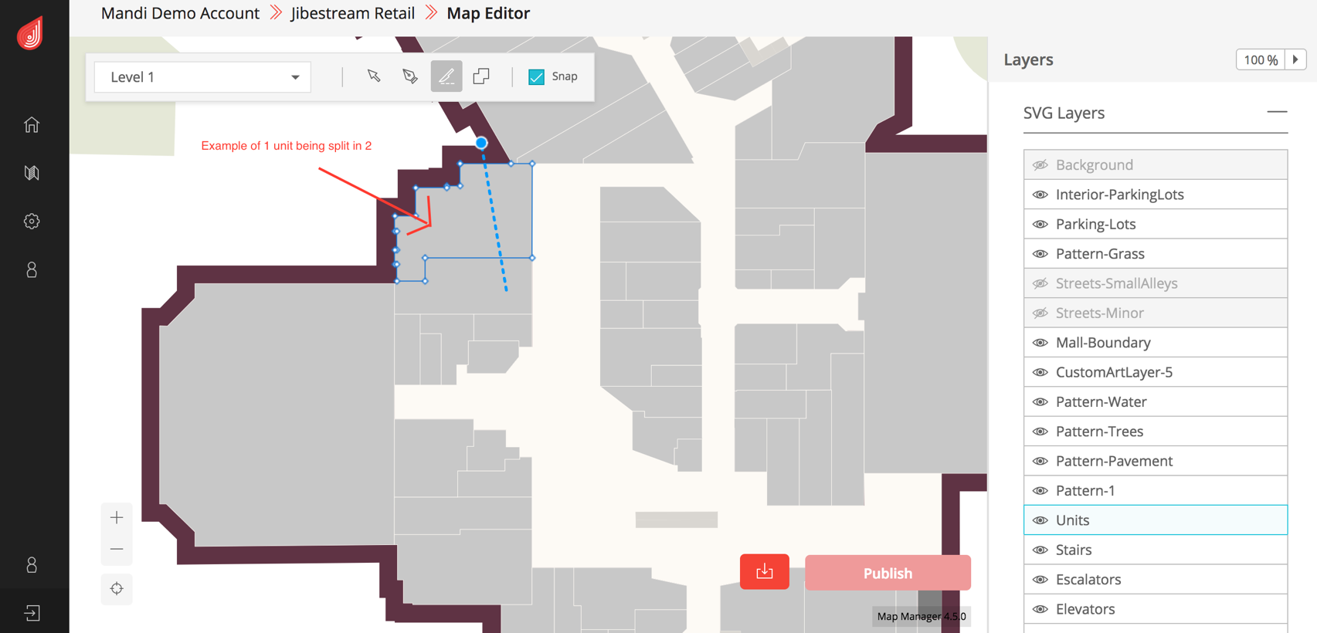

**REQ 2.4 Possibility to upload CAD / other files for layout plot: Fully Supported**

Jibestream CMS allows uploading files in JPEG or PNG format only. This file can be used as a reference image for layout plot. If you have a CAD file available, it is easy to save it as JPEG or PNG before uploading it to Jibestream CMS. Below is an example of how that is done.

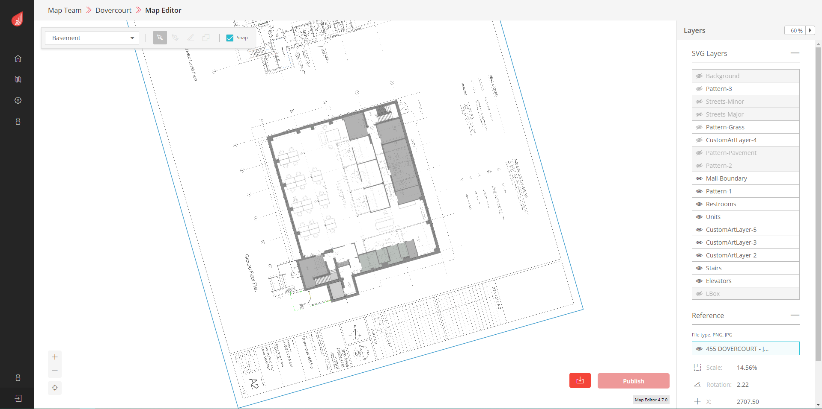

**REQ 2.5 Possibility to change all layouts: Fully Supported**

As mentioned in REQ 2.3, Jibestream CMS’s Map Editor feature allows to make any kind of change to the layouts. Jibestream offers a bonus feature where you are able to EXPORT the floor plan to CAD-friendly format. Please see the screenshot below for an example.

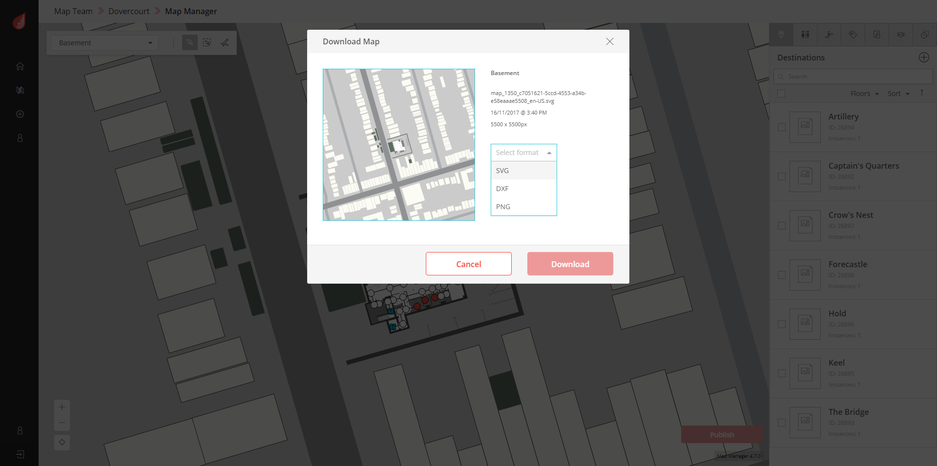

**REQ 2.6 User Level and Permission Management: Fully Supported**

Jibestream has a number of predefined roles that allow for segregation of duties, and access controls to different venues.

Our APIs also have the ability to allow read write access control via email accounts, and read only venue information via OAuth2 client credentials.

**REQ 2.7 Possibility to export information to excel and upload for batch update: Fully Supported**

Jibestream platform allows you to export information to excel in the .csv format and upload for batch update.

**REQ 2.8 Possibility treat points of interest (information, WC, escalators, etc.): Fully Supported**

Jibestream CMS offers an Easy-To-Use interface to make real-time or scheduled changes to the Points of Interest (information, WC, escalators, etc.).

**REQ 2.9 Possibility treat temporary closures: Fully Supported**

Jibestream CMS allows you to make Real-Time changes to the venue if there are temporary closures.

**REQ 2.10 Possibility treat different schedules: Fully Supported**

Our platform allows you to schedule changes in order to automate them.

**INTEGRATION REQUIREMENTS**

**REQ 3.1 Possibility to get external information from other sources (ex: promotions): Fully Supported**

Our solution is built on RESTful architecture principles allowing for maximum interoperability between the platform and 3rd party systems and data. We can choose specific APIs and functionality from the SDKs to create tailored solutions while having centralized management of all associated data. In addition, our platform can run inside secure networks and enables you to maintain control of all proprietary data.  
  
Jibestream’s Integration capabilities for both Push and Pull integrations with 3rd party systems enable a wide range of integrations to visualize real-time location data in the context of a map. Several ‘standard’ integrations come with the Jibestream software, however, the software is designed to be extensible for new data integrations.   
Jibestream ‘Out of the Box’ Integrations:  
  
• indoo.rs Indoor Positioning System  
• MS Exchange Server  
• JD Edwards Content Management System  
• Inrix Predictive Parking  
• WordPress CMS  
• Tenant Management Systems (multiple)  
  
Jibestream enables Web API updates from 3rd party systems facilitating integrations from a myriad of sources making it easier to continue to evolve the application over time. Our platform is designed to support the integration of virtually any data with a location component, in the context of a map. Such integrations could include the following and should be discussed further:

• Facilities Management Systems (i.e FM:Systems)  
• Emergency Messaging  
• Asset Tracking and Asset Management  
• Security Systems

Jibestream Active (‘Swagger”) documentation: <http://demo-api.jibestream.com/JACS/>

**REQ 3.2 Webservice/API for ALL content update or external integration: Fully Supported**

Please see answer for REQ 3.1

**REQ 3.3 Webservice/API for ALL content fetch and search or external integration: Fully Supported**

Please see answer for REQ 3.1



**Our Offer**

**Jibestream Deliverables (POC)**

The development of phase 1 will comprise of a map digitization, implementation and set up of IPS (indoor positioning system). The details are as follows:

|  |  |
| --- | --- |
| **Professional Services (One Time):**   * 4 malls (2 big + 2 small)   **$53,000 USD**   * 2 malls (1 big + 1 small)   **$38,000 USD**   * After POC, while deploying at scale, adding each additional venue will range from **$2500 to $4000 per venue** **(USD).** | **Mapping (provided by Jibestream)**   * Design * Map Digitization + Wayfinding * Consultancy * Dedicated Solutions Engineering * Dedicated Front End/SDK Development support * Support for iOS, Android, and Web (Wayfinder) * Dedicated Back End Development support * QA * Project Management * Deployment * Integration * CMS + Wayfinding Training |
| Annual Licensing: **$3500 USD**  **per venue per year** | * Customer Success & Support * Access to Full Software Documentation * Access to New Software Releases * Access to Product and Solution Engineering Team * Cloud Hosting |

**Intellectual Property**

It is understood and acknowledged, that all IP (for example, but not limited to ideas, concepts, software and other items) which is developed by Jibestream is fully owned by Jibestream. It is the sole decision of Jibestream to (re)use this IP for further product development, other solutions or any other purpose.

**Terms**

* Sonae Sierra must commit to engaging Jibestream for the enterprise-wide deployment within a 12-month period, not just the initial deployment, to benefit from this pricing offer.
* Fees above reflect a 3-year term effective from the date of the start of the first implementation.

/Users/Jibestream/Desktop/Jibestream_logo-horizontal-colour.png

**Vinay Iyer**, Account Executive

[viyer@jibestream.com](mailto:viyer@jibestream.com)

647-252-2909

5